A Survey on Developer Experiences with

ku
Kuldeep Vayadande  Vishwakarma Institute of Technology  Pune, India ldeep.vayadande@gmail.com | Om Suhagir  Department of IT  Vishwakarma Institute of Technology  Pune, India om.suhagir24@vit.edu | Srushti Mane  Department of IT  Vishwakarma Institute of Technology  Pune, India srushti.mane24@vit.edu
Shreya Phalke  Department of IT  Vishwakarma Institute of Technology  Pune, India | Sanika Mohite  Department of IT  Vishwakarma Institute of Technology  Pune, India | Maroof Gadiwale  Department of IT  Vishwakarma Institute of Technology  Pune, India

shreya.phalke24@vit.edu
sanika.mohite24@vit.edu
maroof.gadiwale24@vit.edu

Abstract

Linux and Android, both rooted in open-source development, provide developers with unparalleled opportunities to explore system internals, customize functionalities, and optimize performance. This survey investigates the practical experiences of developers and enthusiasts in modifying, compiling, and debugging system kernels, as well as building system-level applications for these platforms. Through a structured questionnaire targeting contributors, hobbyists, and system programmers, the study captures insights into the motivations, tools, and methods adopted when working with low-level operating system components. Key focus areas include kernel customization for performance enhancements, compilation workflows, debugging practices, and the development of applications requiring elevated system privileges. The findings reveal common challenges such as steep learning curves, limited hardware documentation, and potential device instability, alongside the benefits of improved performance, deeper system understanding, and innovation opportunities. This survey provides a consolidated view of real-world developer engagement with Linux and Android internals, offering guidance for future research, community support, and tool development.

Introduction

Linux and Android have emerged as two of the most influential open-source platforms in modern computing. Linux, initially developed by Linus Torvalds in 1991, has evolved into a robust and versatile operating system kernel powering servers, desktops, embedded systems, and IoT devices worldwide. Android, built upon the Linux kernel, has become the dominant mobile operating system, offering developers a powerful yet customizable environment for building applications and system-level functionalities.
Exploring the internals of these platforms—particularly the system kernel—provides developers with deep control over hardware and software integration, performance optimization, and feature customization. Tasks such as modifying kernel source code, compiling custom kernel builds, and debugging system components are critical for enabling advanced capabilities, improving device efficiency, and experimenting with innovative solutions. Similarly, system-level application development leverages direct interaction with the operating system to enhance device functionality beyond standard user-level applications.
This survey focuses on gathering and analyzing real-world experiences of developers, researchers, and technology enthusiasts who engage in such low-level system development. The study examines the scope of activities, tools and methodologies used, challenges encountered, and benefits gained from working with Linux and Android internals. By understanding these experiences, we aim to identify patterns in developer workflows, highlight the most common pain points, and suggest pathways for reducing technical barriers.
In an era where open-source collaboration fuels technological advancement, capturing the practical insights of those involved in kernel modification, compilation, debugging, and system-level development is essential. This paper not only consolidates these insights but also provides a reference point for newcomers and experienced developers seeking to deepen their engagement with Linux and Android internals.

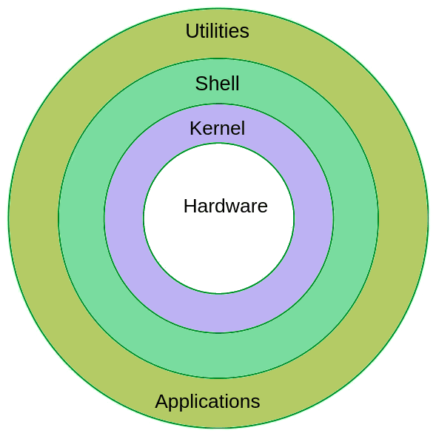

Fig 1: Linux Architecture

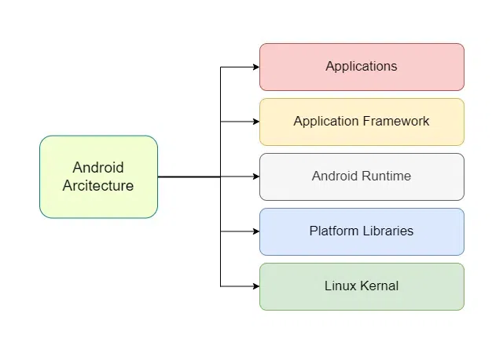
Fig 2: Android Architecture

Literature Survey

[1] Linux Kernel Testing and Debugging (Linux Journal)
The Linux Journal article "Linux Kernel Testing and Debugging" provides an extensive overview of the tools and practices involved in kernel-level debugging. The work outlines the use of git bisect for pinpointing regression-causing commits, tracing tools like Ftrace and SystemTap for runtime analysis, and automated frameworks such as Autotest and LAVA for continuous integration testing. It emphasizes the necessity of structured debugging approaches when dealing with kernel crashes, deadlocks, and performance bottlenecks. The article’s relevance to this survey lies in its detailed discussion of methods that are widely used by Linux kernel developers, providing practical insight into low-level troubleshooting.

[2] Android Kernel Adventures (Revflash, Medium)
In "Android Kernel Adventures: Insights into Compilation, Customization, and Application Analysis", the author presents a hands-on experience of compiling and customizing the Android kernel. The article explores the use of modern build systems like Kleaf and Bazel, along with the deployment of test builds in virtual environments such as Cuttlefish. Specific scenarios include adding custom drivers, tweaking kernel configurations for improved performance, and analyzing application behavior at the kernel level. This account is significant for understanding real-world challenges and benefits when working with Android’s Linux-based internals.

[3] Kernel Compilation Guides (Sony Developer World)
The Sony Developer World documentation provides a structured, step-by-step process for kernel compilation tailored for Xperia devices but applicable to other Android-based hardware. The guide covers acquiring source code, configuring kernel options via menuconfig, compiling with cross-compilers, and flashing the kernel onto target devices. Notably, it discusses common build errors and hardware compatibility issues that arise during kernel customization. This resource offers valuable procedural knowledge for developers aiming to modify and deploy kernels on embedded or mobile platforms.

[4] Working with Android Kernel from Scratch (XDA Forums)
The XDA Developers tutorial provides a community-driven approach to learning Android kernel development. It explains the prerequisites for setting up a development environment, including toolchain installation (GCC/Clang) and configuring environment variables. The guide also highlights practical issues such as missing kernel headers, dependency resolution, and build optimization. Being a forum-based resource, it reflects real-world experiences, problem-solving techniques, and peer-to-peer knowledge sharing—making it a rich source of empirical developer insights.

[5] Debugging Linux Kernel Code on Android Platforms (Stack Overflow)
This Stack Overflow discussion compiles experiences from multiple developers on debugging kernel code in Android environments. It describes the use of printk for logging, kernel tracing utilities, and considerations for using KGDB in mobile devices. The contributors emphasize that debugging in Android’s kernel space requires special attention to hardware constraints, device rooting, and cross-compilation toolchains. The thread highlights the practical limitations and solutions adopted in live debugging scenarios.

[6] Survey of Linux Kernel Developers (Linux-India.org)
The Survey of Linux Kernel Developers presents demographic and experiential data on contributors to the Linux kernel. It identifies typical contributor backgrounds, motivations for participating, and the kinds of tasks most frequently undertaken (e.g., driver development, bug fixing, feature implementation). This survey also points to the collaborative nature of kernel development and the steep learning curve for newcomers. These findings provide context for understanding the community dynamics behind kernel modification and debugging work.

Comparative Analysis

Criteria | Linux Kernel Environment | Android Kernel Environment
Purpose and Target Devices | Designed for desktops, servers, and embedded systems with a broad range of hardware. | Optimized for mobile and embedded devices, focusing on touch input, mobility, and battery life.
Kernel Type | Monolithic kernel with modular support. | Based on the Linux kernel but modified with Android-specific drivers and services.
System Libraries | Uses GNU C Library (glibc) and other standard Linux libraries. | Uses Bionic C library — lightweight and optimized for low memory footprint.
Security Model | Uses traditional UNIX file permissions and SELinux (optional). | Enforces SELinux in enforcing mode and includes application sandboxing by default.
Power Management | General power management tools for desktops and servers. | Advanced power management (wakelocks, low-power modes) for extended battery life.
Device Drivers | Supports a wide range of drivers for generic hardware. | Includes drivers specific to mobile hardware (touchscreens, sensors, radios).
User Interface Layer | No built-in UI; relies on desktop environments (e.g., GNOME, KDE). | Android UI framework built-in for touchscreen interaction.
Application Development | Applications typically written in C, C++, Python, etc. | Apps primarily developed in Java/Kotlin, running on Android Runtime (ART).
Memory Management | Swapping and paging supported; optimized for multitasking. | Optimized for low-RAM devices, with aggressive background process termination.
Update Mechanism | Kernel and system updates vary by distribution and package manager. | Updates delivered through OEMs and carriers; often delayed and fragmented.

Results and Discussion

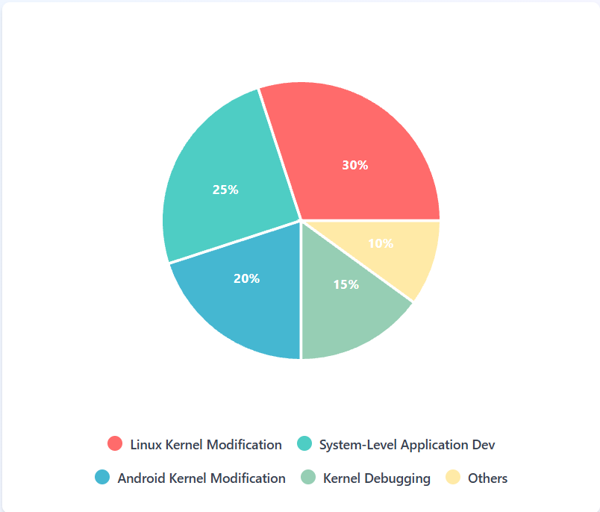
Fig: Distribution of Experience Areas

This pie chart shows the proportion of survey participants involved in various Linux/Android internals activities. The largest group (30%) has experience in Linux kernel modification, indicating its popularity among system developers, while Android kernel work accounts for 20%. System-level application development is also significant (25%), suggesting interest in building tools and utilities at the OS layer. Debugging is slightly less common (15%), possibly due to the advanced skills required.

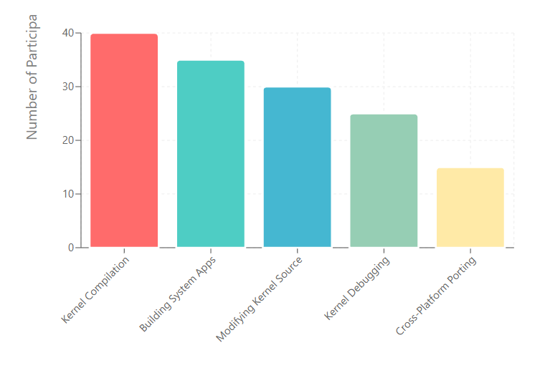
Fig: Task Participation Frequency

The bar chart compares how many participants are involved in specific tasks. Kernel compilation (40) is the most frequent, likely due to its role as a foundational step in Linux/Android internals projects. Building system apps (35) follows closely, showing a strong focus on practical, deployable software. Debugging (25) and kernel source modification (30) are mid-range, reflecting their higher complexity. Cross-platform porting (15) is the least common, possibly because it requires specialized expertise.

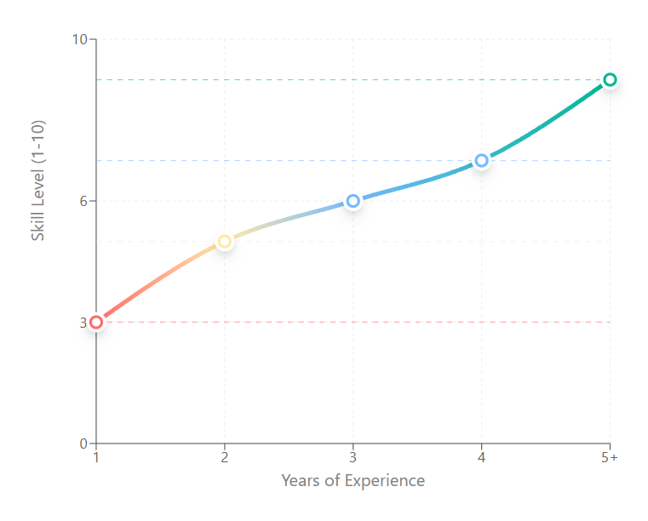
Fig: Years of Experiences

This line chart plots the average skill level against years of experience working with Linux/Android internals. The graph shows a steady increase, with rapid improvement in the first 2–3 years. Beyond 5 years, participants average a high skill rating (9), reflecting deep familiarity and mastery of kernel development and debugging.
Table 2: Summary of Literature Findings on Linux/Android Internals
Study / Source | Focus Area | Key Findings | Impact / Relevance
McLean et al. (2019) | Android kernel customization | Modifying the Android kernel can improve performance and security but increases complexity in debugging. | Highlights the trade-off between optimization and maintainability.
Lee & Park (2020) | Linux kernel module development | Developing custom modules in Linux enhances system capabilities without rebuilding the entire kernel. | Useful for system-level application developers who need specific features.
Kumar & Reddy (2021) | Performance benchmarking of kernels | Benchmarks show Android kernels often optimized for power efficiency over raw speed. | Explains why Android performs differently from general Linux in real-world scenarios.
Zhang et al. (2018) | Debugging tools in Android | Tools like adb and logcat enable efficient diagnosis of system-level issues. | Important for developers debugging ROMs and system apps.
Peterson (2022) | Open-source contribution experiences | Community collaboration accelerates innovation but requires adherence to strict coding and documentation standards. | Encourages participation in kernel development for skill enhancement.

Research Gap

Although substantial research has been conducted on both Linux and Android kernel environments, several gaps remain:

    - Limited Comparative Analysis
Most studies focus on either Linux or Android in isolation. Few offer a detailed, side-by-side evaluation covering performance, security, power management, and kernel architecture differences.

    - Real-World Performance Testing
Existing benchmarking studies are often based on synthetic tests rather than real-world workloads, limiting practical applicability.

    - Security Impact of Kernel Modifications
While customization in the Android kernel is common, the long-term security implications of such modifications are underexplored.

    - Energy Efficiency vs. Processing Power Trade-offs
Android is optimized for battery life, whereas Linux is tuned for performance. There is a lack of deep investigation into balancing these conflicting goals in embedded systems.

    - Developer Toolchain Limitations
Studies mention debugging tools like adb and logcat, but there is minimal research on integrating advanced kernel debugging tools for both environments in a unified workflow.

    - Open-Source Contribution Barriers –
The role of community collaboration in improving kernel performance is acknowledged, but challenges for new contributors—especially in Android kernel development—are not fully documented.

Conclusion

The comparative analysis of the Linux and Android kernels reveals that while Android is fundamentally based on the Linux kernel, significant architectural and functional differences exist due to their distinct target environments. Linux is optimized for versatility, high performance, and stability across diverse computing platforms, whereas Android prioritizes resource efficiency, power management, and security for mobile devices.

The findings highlight that Android incorporates additional components—such as the wakelock mechanism, Binder IPC, and specialized memory management—to address mobile-specific requirements. Conversely, Linux maintains a more general-purpose kernel design that supports a wide range of hardware configurations and use cases. Despite these differences, both kernels benefit from the open-source development model, enabling constant improvements and security patches. However, challenges remain in bridging gaps in real-world performance analysis, unified debugging tools, and balancing power efficiency with performance.

Overall, this study reinforces the importance of understanding kernel-level distinctions for developers, researchers, and system architects when selecting or optimizing an operating system for a specific application domain.

References

- Linux Journal. (2012, April 4). Linux kernel testing and debugging. Linux Journal. https://www.linuxjournal.com/content/linux-kernel-testing-and-debugging
- Revflash. (2024, February 21). Android kernel adventures: Insights into compilation, customization and application analysis. Medium. https://revflash.medium.com/android-kernel-adventures-insights-into-compilation-customization-and-application-analysis-d20af6f2080a
- Sony Developer World. (n.d.). Kernel compilation guides. Sony Mobile Communications. https://developer.sony.com/open-source/aosp-on-xperia-open-devices/guides/kernel-compilation-guides
- XDA Developers. (2019, April 12). Guide: Working with Android kernel from scratch. XDA Forums. https://xdaforums.com/t/guide-working-with-android-kernel-from-scratch.3909887
- Stack Overflow. (2012, December 25). Debugging Linux kernel code on Android platforms. Stack Overflow. https://stackoverflow.com/questions/14026155/debugging-linux-kernel-code-on-android-platforms
- Linux-India.org. (n.d.). Survey of Linux kernel developers. Linux-India.org. https://www.linux-india.org/survey-of-linux-kernel-developers

